Experiment 3 Projectile Motion
Section Number: PHYS1103. ___ Date:__/__/____
Group Number:___
 | Dept | Student Number | Name | Surname | Task Distribution
1
2
3

Objectives
- To understand the effects of initial velocity and launch angle on the maximum height and range of an object
- To understand the impact of mass on the motion of an object
- To conclude comparing experimental and theoretical results

Equipment List

- Projectile Launcher (Figure 1)
- Steel Ball
- Wooden Ball
- Video Recorder
- Paper
- Ruler

Procedures:
At each experiment video of the motion of the balls must be recorded to measure distances and velocities.
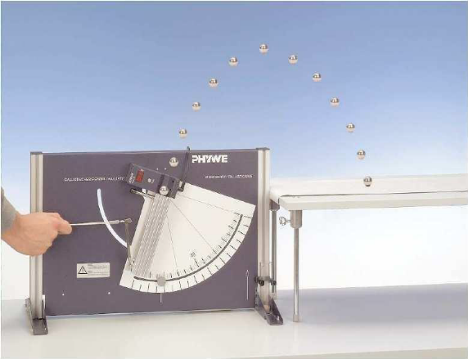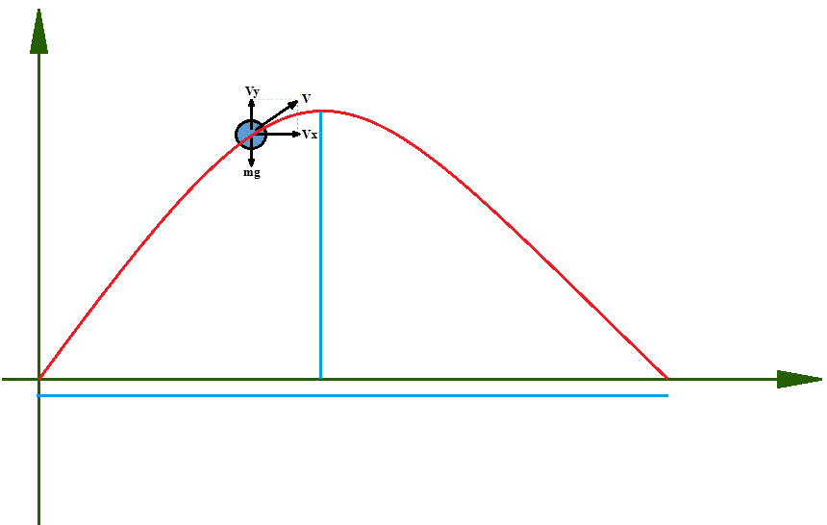
Figure 1. Projectile Launcher
Figure 2. Projectile Launcher
R
h_{max}
θ
v₀

Part 1
- For the first level of the starter unit set the angle to 30° and use the steel ball.
- Throw the ball from the first level of the starter.
- Record the initial velocity and range of the ball in the Table 1.
- Repeat the steps 1 to 3 for 45 and 60 degrees of the launcher.
- Set the launcher to the second level
- Throw the steel ball at the 30°
- Record the initial velocity and range of the ball in Table 2.

Part 2
- Use the wooden ball and repeat the experiment for angle 30° for first levels.
- Record the initial velocity and range of the ball in Table 3.

Processing data and making calculations
- Find the throwing and impact angles, the maximum height, the range, initial and final velocities of the ball by image processing method
- Calculate the maximum height and the range of the ball for each part.
- Use the data obtained from image processing software, plot the three experiments of the ball's motion on the same graph for each throwing angle.
- Write average values of maximum height and range of balls obtained from experiment, calculations and image processing in Table 4, Table 6 and Table 8.
- Write the % of error according to theoretical calculations in Table 5, Table 7 and Table 9
- Plot bar graphs of range and h_{max} vs. angles for each part.

Related Equations:

Table 1. Measured velocities and range of the steel ball at first level of launcher
 |  | 30º | 45º | 60º
V₀ (m/s) | 1
V₀ (m/s) | 2
V₀ (m/s) | 3
V₀ (m/s) | Average
R (m) | 1
R (m) | 2
R (m) | 3
R (m) | Average

Table 2. Measured values of the steel ball at the second level of the launcher
 |  | 30º
V₀ (m/s) | 1
V₀ (m/s) | 2
V₀ (m/s) | 3
V₀ (m/s) | Average
R (m) | 1
R (m) | 2
R (m) | 3
R (m) | Average

Table 3. Measured values of the wooden ball
 |  | 30º
V₀ (m/s) | 1
V₀ (m/s) | 2
V₀ (m/s) | 3
V₀ (m/s) | Average
R (m) | 1
R (m) | 2
R (m) | 3
R (m) | Average

Table 4. Values of initial velocity, range and maximum height of the steel ball thrown at the first level of the launcher obtained experimentally, calculated and software
 |  | 30º | 45º | 60º
V₀ (m/s) | Experiment
V₀ (m/s) | Software
V₀ (m/s) | Calculation
R (m) | Experiment
R (m) | Software
R (m) | Calculation
h_{max} (m) | Experiment
h_{max} (m) | Software
h_{max} (m) | Calculation

Table 5. % error of the initial velocity, range and maximum height of the steel ball thrown from the first level of the launcher according to the calculated values.
 |  | 30º | 45º | 60º
V₀ (m/s) | Experiment
V₀ (m/s) | Software
R (m) | Experiment
R (m) | Software
h_{max} (m) | Experiment
h_{max} (m) | Software

Table 6. Values of initial velocity, range and maximum height of the steel ball thrown at the second level of the launcher obtained experimentally, calculated and software
 |  | 30º
V₀ (m/s) | Experiment
V₀ (m/s) | Software
V₀ (m/s) | Calculation
R (m) | Experiment
R (m) | Software
R (m) | Calculation
h_{max} (m) | Experiment
h_{max} (m) | Software
h_{max} (m) | Calculation

Table 7. % error of the initial speed, range and maximum height of the steel ball thrown from the second level of the launcher according to the calculated values.
 |  | 30º
V₀ (m/s) | Experiment
V₀ (m/s) | Software
R (m) | Experiment
R (m) | Software
h_{max} (m) | Experiment
h_{max} (m) | Software

Table 8. Values of initial velocity, range and maximum height of the wooden ball thrown at the first level of the launcher obtained experimentally, calculated and software
 |  | 30º
V₀ (m/s) | Experiment
V₀ (m/s) | Software
V₀ (m/s) | Calculation
R (m) | Experiment
R (m) | Software
R (m) | Calculation
h_{max} (m) | Experiment
h_{max} (m) | Software
h_{max} (m) | Calculation

Table 9. % error of the initial speed, range and maximum height of the wooden ball thrown from the first level of the launcher according to the calculated values.
 |  | 30º
V₀ (m/s) | Experiment
V₀ (m/s) | Software
R (m) | Experiment
R (m) | Software
h_{max} (m) | Experiment
h_{max} (m) | Software

